**Low-cost artificial automated breathing unit**

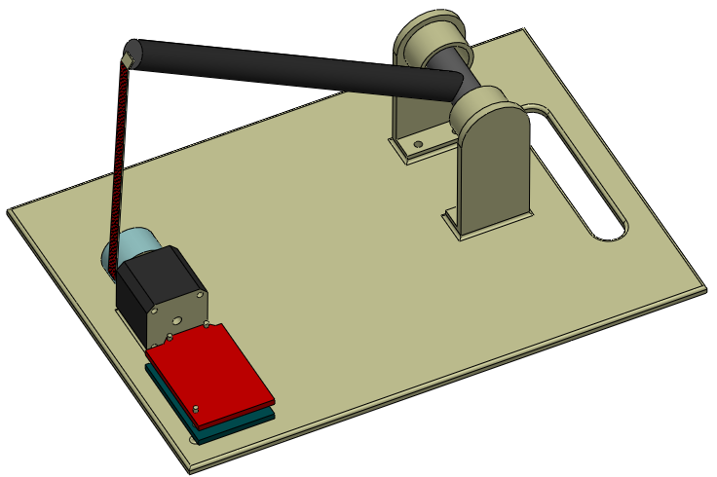

Figure 1. 3D projection of the CAD drawing of the ventilator (without AMBU bag). This class 2 lever design is as follows: The arm/lever, is shown as a black color rod, a ‘T’ joint assembly is its fulcrum. The arm is rotatable about this fulcrum. A flat belt is connected to the other end of the arm. A stepper motor, shown as black cube, winds the belt around the pulley attached to the shaft of the motor. The red and blue color boards shown are V3 CNC shield with stepper motor driver and Arduino-Uno respectively. All of these components are mounted on a base with a provision for holding.

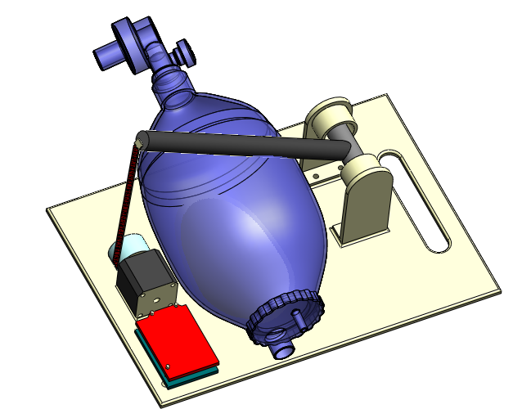

Figure 2. 3D projection of the CAD drawing of the ventilator with AMBU bag. Here the AMBU bag and valve assembly are shown in blue color. Face mask, oxygen reservoir and oxygen supply pipes are omitted for simplicity. The size of the base plate is 34cm x 24cm.

As the stepper motor, shown in Figure.1 and Figure. 2 rotates, the belt gets pulled and winds around the pulley. During this time the arm gets rotated about the T-joint (fulcrum) and compresses the AMBU bag. During this time the air/oxygen in the AMBU bag gets pressurized letting the outlet valve to open and is pushed into the lungs of the patient through a fish-mouth type non-rebreathing valve. This is called *inspiratory process* of the ventilator during which the patient’s lungs are pressurized. The inspiratory flow time can be controlled by adjusting the speed of the stepper motor. The volume of the gas (*tidal volume*) entering into the lungs can be adjusted by varying the angle of rotation of the lever. At the end of the inspiratory process, the stepper motor waits for a period, called the *inspiratory pause*. This time can also be varied. Once the inspiratory pause is over the stepper motor rotates back to its original position allowing lever to rotate back decompressing the silicone bag. This allows the fresh air/oxygen to enter into the AMBU bag through the oxygen inlet valve (bag inlet valve). Supply from a nebulizer can also be attached to the oxygen inlet pipe if the patient require medication. During this time the patient breath out through a flap valve due to the positive pressure inside the lungs. This time is known as *expiratory flow time*. The expiratory time can be controlled by adjusting the reverse rotation speed and the holding time. Toward the end of the expiration there will be a pause known as *expiratory pause*. The time taken for all these processes together is called the *ventilatory period*. The entire process repeats.

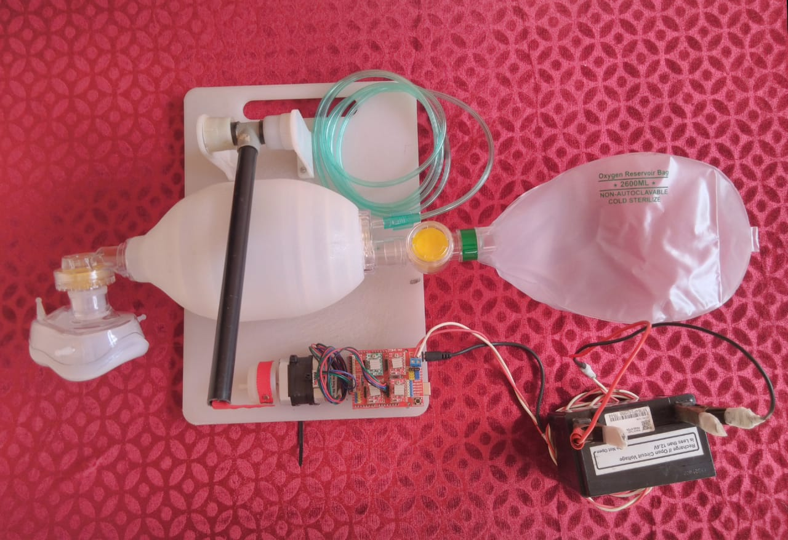

Figure 4. Photograph of the prototype ventilator. Face mask, Oxygen reservoir, Oxygen supply pipe, 12V battery and oxygen regulatory valve are also shown here.

This ventilator can work in invasive (with face mask) mode and noninvasive mode (with ET tube) depending upon the doctor’s suggestion. With our basic design a medical practitioner should be able to adjust the following parameters from the control panel

1. Ventilatory period (no. of cycles per minute),
2. Inspiratory flow time,
3. Inspiratory pause
4. Expiratory time.

With the current design all these parameters are controlled electronically by a microcontroller circuit and hence multiple feed backs from the patient’s body response, external gas supplies etc. can be incorporated easily.

Another major design consideration using AMBU bags is that even though the unit is automated, doctors/medical personals will still be able to switch over to a completely manual mode of operation say in case of a power failure. They will be able to operate the lever mechanism by hand as per the situation. Not to mention AMBU units can easily be replaced or can be operated outside if necessary. The small form factor of the design will make sure that the units could easily be installed near or under the beds of the patients.

The following safety features will be in place with the final design:

1. The unit can be operated with battery in addition to a 12 V power supply.
2. Dual operation: Automated and manual modes (in case of any emergency)
3. Patient emergency alarm
4. Pressure limiting valve

The operation of this equipment is video graphed and posted in YouTube. This is available in the following link.

<https://youtu.be/Y424bS-fKAs>

List of components used

|  |  |  |  |
| --- | --- | --- | --- |
| Si. No. | Item | Dimension | Price |
| 1 | Silicon resuscitator (AMBU) | Adult size (1-2L) | 1700 |
| 2 | Stepper motor | NEMA 17 | 600 |
| 3 | Arduino UNO |  | 450 |
| 4 | V3 CNC Shield for uno |  | 200 |
| 5 | Pololu Stepper motor driver | A4988 | 200 |
| 6 | Arm-PVC pipe (½ inch dia.) | 10-inch length | 50 |
| 7 | PVC -T ½ inch |  | 15 |
| 8 | Curtain pipe holder (3/4 inch) 2 No |  | 50 |
| 9 | Base board Plastic | 34cm x 24 cm | 150 |
| 10 | Connection wires and screws |  | 100 |

Arduino Program

#include <AccelStepper.h>

# define EN 8 // stepper motor enable , active low

AccelStepper Xaxis(1, 2, 5); // pin 2 = step, pin 5 = direction

void step (int steps)// steps is the no of steps to move each step is 1.8 deg

{

Xaxis.move(steps);

Xaxis.runToPosition();

}

void setup()

{

pinMode (EN, OUTPUT); // Pin 8 of UNO EN enable stepper motor

digitalWrite (EN, LOW); //activate stepper motor

Xaxis.setMaxSpeed(1000);// step per second

Xaxis.setAcceleration(12000); // Acceleration control for

//smooth starting and ending

}

void loop()

{

step (250); //Inspiartory flow

delay (900); //Inspitatory pause time

step (-250); // Expiratory flow

delay (900); // Expiratory pause time

}

*PROS:*

1. Many adjustable parameters— Ventilatory period, tidal volume etc.
2. Simple design and readily available spare parts

*CONS:*

1. Not essentially optimized for extremely critical patients who might need ICU support.

**Alternate design**

An alternate simpler design is also proposed here where the ventilator is operated purely electrically with the stepper motor replaced with a DC motor, operated through a two-way switch, and hence the any requirement of microcontroller circuit is eliminated. The use of geared DC motor (for torque enhancement) will reduce the price of such unit however compromising few of the features.

**Operating principle**

When the unit is switched ON, the unit will start with the *inspiratory process.* During this the DC motor will wind the tape pulling the lever downward and compressing the silicone bag. The lever mechanism when pulled down and reaches a mechanical set point it reverses the two-way switch which in turn reverses the direction of rotation of the DC motor. In this way the system switches over to expiration process, thus completing a full cycle. The mechanical set point will be used to adjust the volume of the air/oxygen pumped into lungs of the patient. The rotation speed of the motor will be varied electrically by controlling the power to the motor. This unit will have minimum electronics and hence the operation and maintenance will be minimal. Additionally, this design can also be operated manually in case of a power failure.

*PROS:*

1. Simple design with no electronic controls.
2. Easy maintenance due to purely mechanical operation.

*CONS:*

1. Lacks few of less essential features like control over inspiratory pause time.
2. Can only be used for less critical patients.
3. **Proposed model of the disposable ventilator**

This ventilator consists of a flexible bellow fabricated using medical grade silicone or a clear multilayer polyolefin plastic film as shown in Figure.5. The volume and shape of the bellow are optimized for delivering right amount of oxygen/air to a patient. A fish-mouth type non-rebreathing valve is attached to one end of the bellow (not shown un figure). This valve is made out of silicon/rubber. A safety valve is also provided to prevent over pressuring the bellow. An expiratory flap valve is also connected at this end (not shown un figure). On the other end, a bellow inlet valve is connected. After this valve an oxygen pressure control valve and an oxygen reservoir are connected. The oxygen reservoir is fabricated using polyolefin plastic film (not shown in the figures).

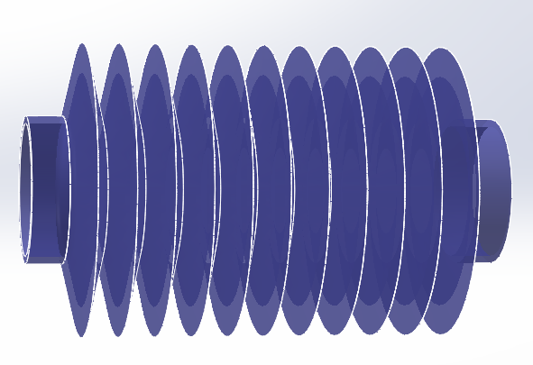

Figure 5 CAD drawing of bellow type manual resuscitator. Valves, masks, oxygen reservoir and oxygen pipes are not shown in this figure.

The 3D CAD drawing of this ventilator is shown in Figure.6 and Figure.7. This ventilator is operated using a geared DC motor. A crank shaft is connected from the disc on the motor to the bellow. Many holes are drilled at different distance from the axis/center of the disc. This allows for varying the displacement of the bellow and hence the volume of the air/oxygen flown can be controlled. The rate of respiration can be controlled by varying the speed of the DC motor. In this design, a microcontroller is eliminated. A DC motor driver is the only electronic component in this design. This further improves the simplicity and reliability. The minimal components used here increases the ease of assembly and maintenance.

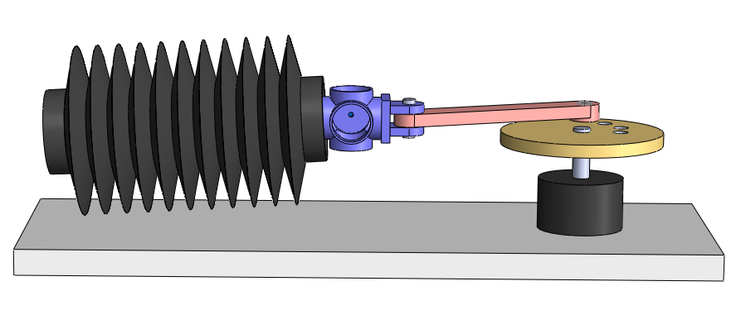

Figure 6. CAD drawing. Side view of the ventilator. The black colored cylinder on the right-hand side is a DC motor. The speed of the dc motor determines the number of respirations per minute.

The valve holder shown in blue color in Figure.6 is fabricated using polyolefin plastic. Here the flywheel and motor cases are made of metal. The crank shaft is fabricated on using ABS plastic or acrylic sheet. The bellow, valve assembly and crank shaft are manufactured using injection molding technique. This reduces the cost drastically. Supply from a nebulizer can also be attached to the oxygen inlet pipe.

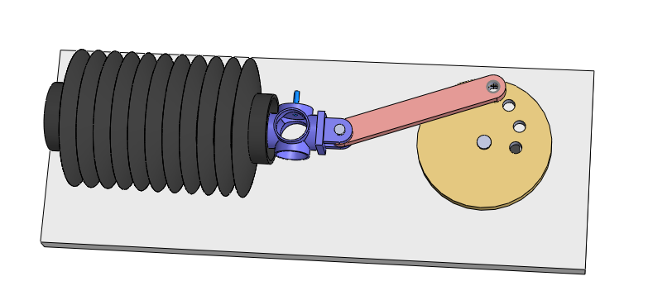

Figure 7. CAD drawing. Top view of the ventilator. The copper colored disc on the right hand-side of the figure is attached to the shaft of the DC motor. Different holes are drilled to this disc. Connecting the crank shaft to different holes allows us to vary the volume of the gas delivered by the bellow.

List of components used

|  |  |  |  |
| --- | --- | --- | --- |
| Si.No. | Item | Dimension | Price |
| 1 | Resuscitator (Bellow type) | Adult size (1-2L) | 1000 |
| 2 | Geared DC Motor | 12V or 6 V | 400 |
| 3 | DC motor Driver |  | 300 |
| 4 | Fly wheel |  | 200 |
| 5 | Cam shaft |  | 100 |
| 6 | Base board Plastic | 34 cm x 24 cm | 150 |
| 7 | Connection wires and screws |  | 100 |